MINISTRY OF EDUCATION AND SCIENCE OF UKRAINE
Lviv Polytechnic National University
Institute of Public Administration,
Governance and Professional Development
University of Applied Sciences for Public Administration, Police and Judicial Administration of the State of Mecklenburg-West Pomerania (Güstrow, Germany)
University of Gdańsk (Gdańsk, Poland)
Higher School of Entrepreneurship named after Prince Casimir Kujawski (Inowroclaw, Poland)
University of Warmia and Mazury (Olsztyn, Poland)

PROGRAM
of the international scientific and practical conference
EUROPEAN INTEGRATION AND TRANSFORMATION OF PUBLIC GOVERNANCE IN UKRAINE
19.04.2024
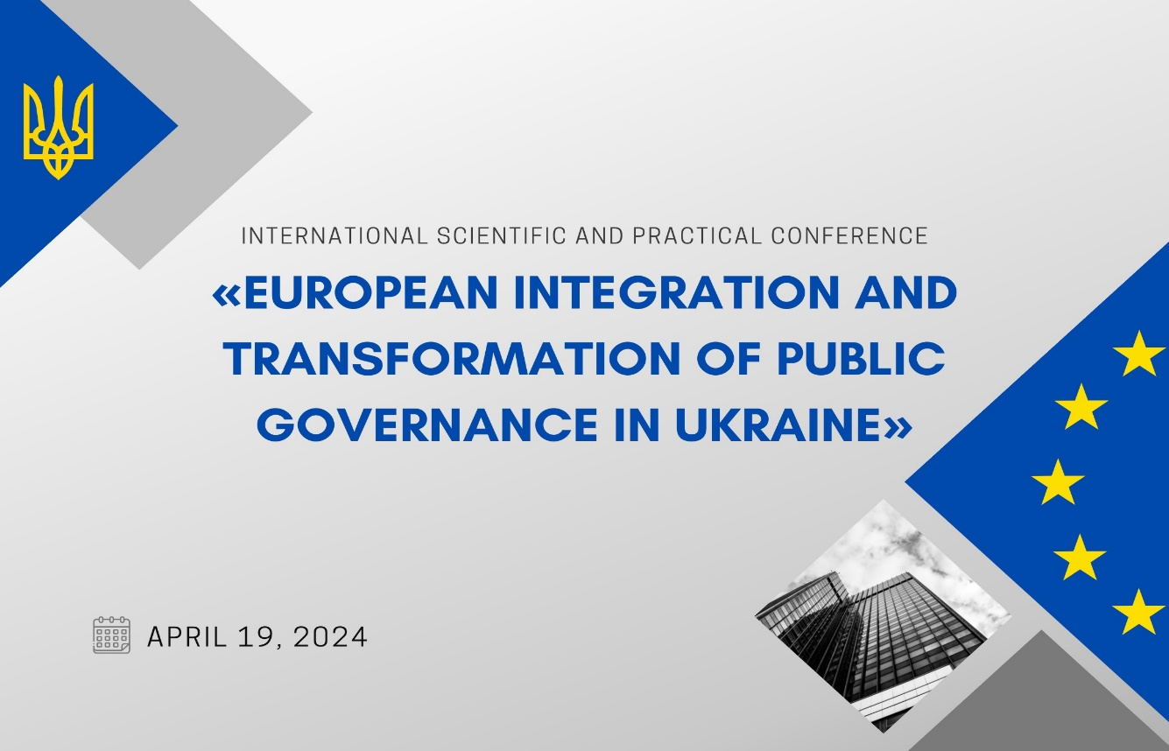
Conference meeting ID: https://us02web.zoom.us/j/2608892447...
Password: 2020
Lviv - 2024

09:00 (European time)
PLENARY SESSION
Moderator: Dr. Mykola Bunyk
Prof. Dr. Orystlava Sydorchuk
Greetings
Prof. Dr. Lubomyr Pylypenko, Director of the Institute of Public Administration, Governance and Professional Development, Lviv Polytechnic National University
Prof. Dr. Holger Franke, Professor of Public Law of the University of Applied Sciences for Public Administration, Police and Judicial Administration of the State of Mecklenburg-West Pomerania ( Güstrow, Germany)
Dr. Wiesław Juchacz, Rector of the Higher School of Entrepreneurship named after Prince Casimir Kujawski (Inowroclaw, Poland)
Dr. Marcin Połom, Director of the Institute of Human Geography and Spatial Management, University of Gdańsk (Poland)

Dr. Thomas Thiesen, University of Applied Sciences for Public Administration, Police and Judicial Administration of the State of Mecklenburg-West Pomerania Fit for constant change? - the conceptual framework and practical challenges of establishing an innovation competent public sector
Dr. Diana Zayats, Associate Professor at the Department of Public Administration and Public Service, Lviv Polytechnic National University “Decentralization reform in Ukraine: achievements to date and implementation prospects amidst war conditions”.
Birke Sander, Juliane Wegner, University of Applied Sciences for Public Administration, Police and Judicial Administration of the State of Mecklenburg-West Pomerania “Hybrid Horizons: Navigating Education's Future with Innovative Pedagogy"
10.35-10.50 Сoffee break
Dr. Anne Melzer, Deputy Director of the University of Applied Sciences for Public Administration, Police and Judicial Administration of the State of Mecklenburg-West Pomerania “From Stability to Agility: Transforming German Policing for the VUCA Environment”
Veronika Gohla, State Chancellery Mecklenburg-Vorpommern, Unit International Relations “Regional partnership as an instrument of international co-operation using the example of Chernihiv and Mecklenburg-Western Pomerania”
Prof. Holger Franke, Professor of Law, University of Applied Sciences for Public Administration, Police and Judicial Administration of the State of Mecklenburg-West Pomerania “Planning and approval of onshore wind-energy- plants in Germany – new legal regulations“
Prof. Yevhen Matviishyn, Professor of Regional and Local Development Department, Lviv Polytechnic National University “Comparative assessment of the activity of regional military administrations of Ukraine in social media”
12.30 Lunch

13:00
СЕКЦІЯ 1. ПРІОРИТЕТИ ПУБЛІЧНОЇ ПОЛІТИКИ УКРАЇНИ В СУЧАСНИХ ГЕОПОЛІТИЧНИХ УМОВАХ
СЕКЦІЯ 2. ВИКЛИКИ ТА ЗАГРОЗИ ДЛЯ ДЕМОКРАТИЧНОГО ВРЯДУВАННЯ ТА ПУБЛІЧНОГО АДМІНІСТРУВАННЯ У ВОЄННИЙ ТА ПОСТ ВОЄННИЙ ПЕРІОДИ.
СЕКЦІЯ 3. ПЕРСПЕКТИВИ ЄВРОПЕЙСЬКОЇ ІНТЕГРАЦІЇ ТА СИСТЕМИ БЕЗПЕКИ У СХІДНІЙ ЄВРОПІ
СЕКЦІЯ 4. ЕКОНОМІЧНІ, СОЦІАЛЬНІ ТА ЕКОЛОГІЧНІ АСПЕКТИ ПУБЛІЧНОГО УПРАВЛІННЯ НА РЕГІОНАЛЬНОМУ РІВНІ

