Dr. David Henry Sacko - bio

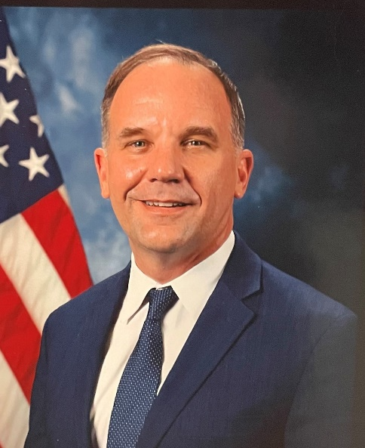
Dr. David H. Sacko is the Brent Scowcroft Professor National Security Studies and Professor of Political Science at the United States Air Force Academy currently at the University of Warsaw’s Centre for Eastern Studies as a Visiting Professor and Fulbright Scholar. Since joining USAFA in June 2002, he has served as a Fulbright Scholar at the University of Warsaw’s International Relations Department in 2007, National Security and International Relations Division Chief and Comparative Politics Division Chief and has completed post-doctoral educational experiences at Washington University, the University of Michigan, Cornell University, and in Kyiv, Ukraine. He holds degrees from the Pennsylvania State University and Binghamton University. He is emeritus Chair of the International Security Section of the American Political Science Association.

Research interests include Russian Federation economic influence in active measure campaigns, Russian strategic culture, Russian civil-military relations, Central European security affairs, and international liberal leadership theory. Recent publications include “Economic Growth’s Catalyzing Effect on War” (2022), “The Regularity of Irregular War: Defining Victory in Endless Wars” in American Defense Policy, 10th Edition (2021), “All Quiet on the Eastern Front: Russia and Japan’s Forgotten Territorial Dispute” in the Journal of Indo-Pacom Affairs (2020). His book The Unipolar World: An Unbalanced Future (Palgrave Press, 2007) situates unipolarity in contemporary world politics scholarship while other publications include articles in International Studies Quarterly, Comparative Technology Transfer and Technology, Nationalism and Ethnic Politics, Contemporary Security Policy, Conflict Management and Development, Journal of Political Science Education as well as contributing chapters to The United States, Russia, and China: Confronting Global Terrorism and Security Challenges in the 21st Century; and five Institute of National Security Studies (INSS) reports.

His research on Polish missile defense won the AF-Institute of National Security top USAFA researcher award. He was named an Outstanding Academy Educator in 2005 and selected by the USAFA class of 2009 as the Heiser Professor of Social Science and Humanities. His teaching has also been honored by the American Political Science Association and the Department of Political Science at USAFA. He has taught various courses including US Foreign and National Security Policy, Causes of War, Politics of Russia, Geopolitics, International Relations Theory.

