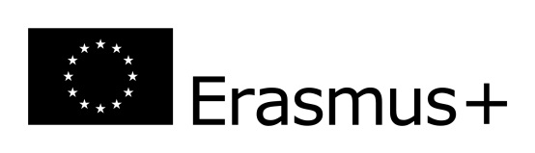
INSTITUTE OF EDUCATION 2017/2018
Courses for ERASMUS student with the groups of Early education and English teaching, Social work
lp | Subject | semester | Hours |  | ECTS points
 | Art and supporting child's artistic creativity-zimowy | winter |  | 30 | 4
 | Music and supporting child's musical creativity | winter |  | 30 | 4
 | Methodology of early English education | winter |  | 30 | 3
 | English with elements of phonetics | winter |  | 30 | 3
 | Childhood in the contemporary world | winter |  | 15 | 2
 | Supporting the child's development in the early education | winter |  | 30 | 4
 | Classroom management | winter |  | 15 | 2
 | Models of early education | winter |  | 15 | 2
 | Picture books for children | winter |  | 10 | 1
 | Integrated course | winter/summer |  | 90/60 | 5/4
 | Polish course | winter/  summer |  | 60/60 | 4/4
 | English for Teachers | winter/  summer |  | 60/60 | 3/3
 | English Grammar | winter/  summer |  | 30/30 | 3/3
 | The pedagogy of Maria Montessori at home and in early education | summer |  | 20 | 2
 | Creative writing | summer |  | 60 | 5
 | Drama and children's play | summer |  | 20 | 2
 | Early science and experimenting) | summer |  | 30 | 4
ERASMUS EXCHANGE IN 2017-18
Dear future Erasmus students. Please note that full list of courses for both winter and summer semesters of 2017/18 academic year will be available on September. Some lectures will be activated after the elections made ​​by the students and the list of items presented in September.
The coordinator of pedagogy:
Magdalena Sawicz wnsms@ug.edu.pl, Room A415 Tuesday, Thursday 8:00-15:00 and arranged meetings

