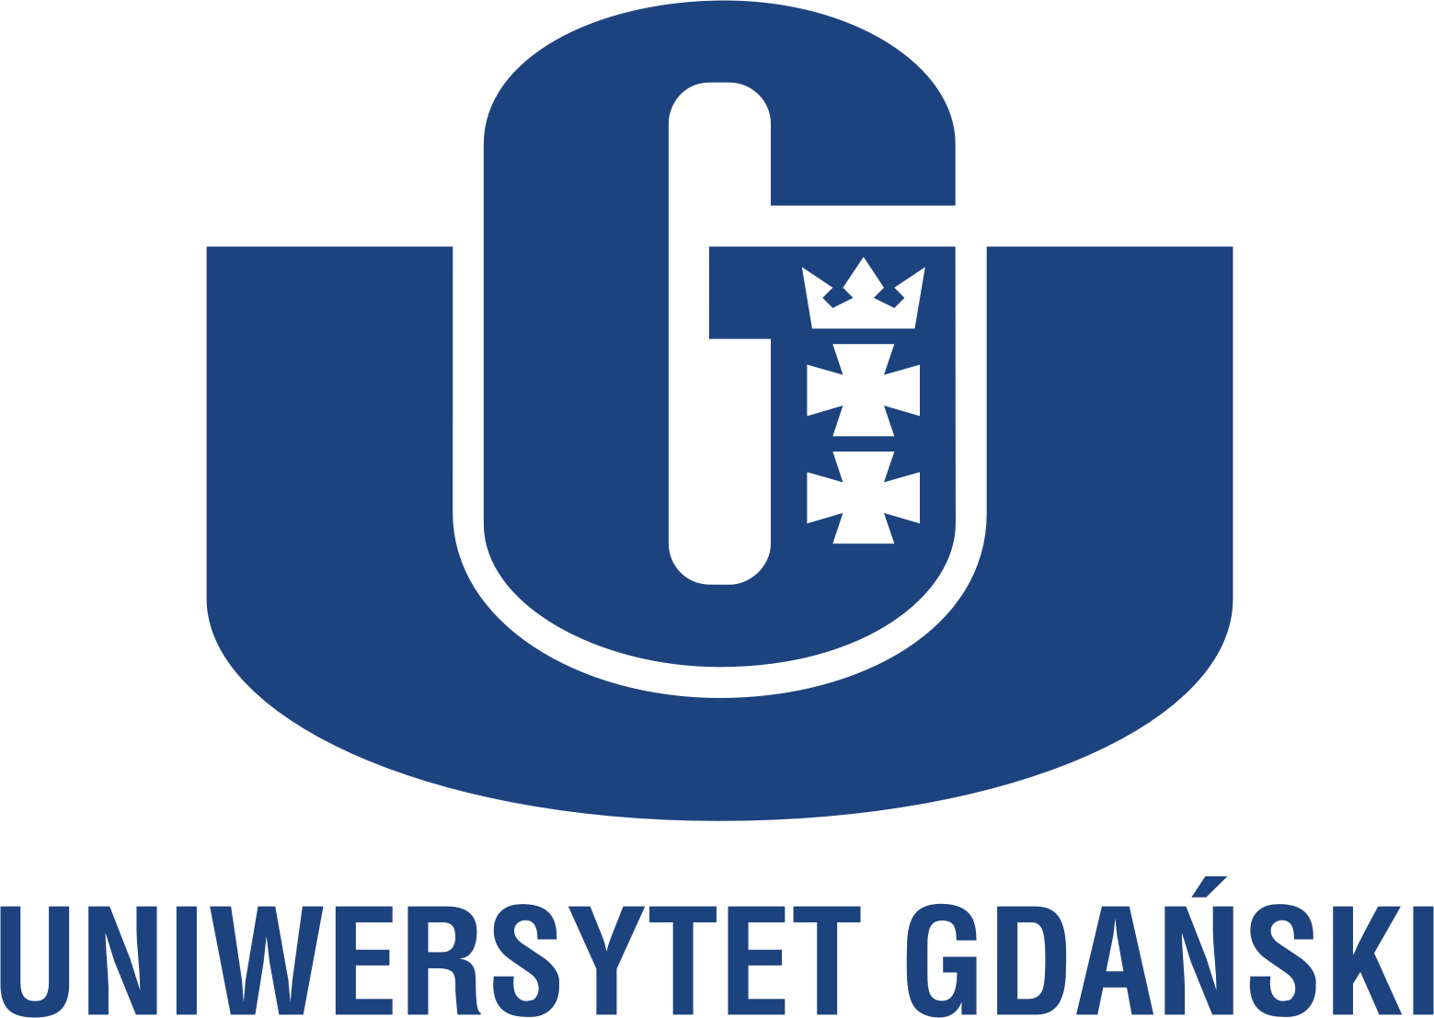 | 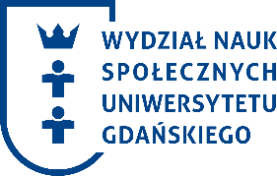

Zakład Badań nad Dzieciństwem i Szkołą
Instytutu Pedagogiki Uniwersytetu Gdańskiego

Science Conference
Holistic aspects of children's education

28 November 2019

University of Gdansk
Faculty of Social Sciences

Scientific Committee
Prof. dr hab. Dorota Klus-Stańska, Uniwersytet Gdański
Ph.D. Dalila Lino, Instituto Politécnico de Lisbona
dr hab. Agnieszka Nowak-Łojewska, prof. nadzw., Uniwersytet Gdański
prof. UWM, dr hab. Marzena Nowicka, Uniwerystet Warmińsko-Mazurski
Amanda Scott, Development Manager at Angus Council

Dear colleagues,

We are honored to invite you to take part in a scientific international meeting. This is one of three conferences implemented as part of the international project THRIECE Teaching for Holistic, Relational and Inclusive Early Childhood Education.

The project is based on three principles:
1. Holistic, which emphasizes the wide overview of the child and takes into deep consideration the cognitive, emotional, social and various experiences of children and their interests.
2. Inclusive, supporting socio-cultural diversity and respect, opposing the exclusion of children due to their different cultural traditions and social background.
3. Relational, emphasizes sense of positive relationships and interactions between teachers and children, children and their peers, as well as parents and the environment and the local community.

The project was created as a result of cooperation of several research centers (Marino Institute of Education in Dublin, Trinity College Dublin, University in Porto and University of Gdansk) and pre-school and early school institutions from Ireland, Portugal and Poland (Carlow Educate Together National School, An Cosan, Tallaght Play Together Childcare, Carlow; Agrupamento de Escolas Alexandre Herculano, Agrupamento de Escolas Soares dos Reis; Play and Education Center "Żyrafa", Gdańsk; School and Kindergarten No. 3, Gdynia).

Our meeting is focused on a holistic overview of the child and their education.

Participants are welcome to take part in following discussions:
1. recognition of children's cognitive potential, emotional and social competences
2. creating learning space, time and tasks to activate children
3. holistic learning and teaching methods
4. declining barriers in applying holistic solutions in working with children

Terms and conditions

The applicants MUST return the application (on the attached form) by October 7th, 2019.
Please send the APPLICATION FORM to dr hab. Agnieszka Nowak-Łojewska, prof. Associate .:
agnieszka.nowak-lojewska@ug.edu.pl

The conference is FREE of charge.
The participants do not cover any charges of participation in the conference or publication of their text after obtaining a positive review.
Conference materials and refreshments during coffee and lunch breaks are provided.

Conference languages: Polish and English.

Editorial information:
Texts up to 14 pages; Times New Roman 12 font; 1.5 line spacing; standard margins; footnotes; bibliography at the end of the text.

Information about accommodation:
Accommodation is not provided, participants organize and pay it for themselves. The closest UG is: Hotel "Olivia" www.hotelolivia.org.pl

Organizing committee:
Professor dr hab. Dorota Klus-Stańska, prof. dr hab. Ewa Szatan, dr hab. prof. Associate. Agnieszka Nowak-Łojewska, dr Grażyna Szyling

WELCOME!

Application Form

Name
Company
Form of participation (please tick the box)
☐ to give a presentation
☐ to attend a discussion panel
title of the presentation

signature

