INTERNATIONAL MASTER “PHILOSOPHY, POLITICS AND ECONOMICS IN MED”
UNIBA - III EDITION 2019-21
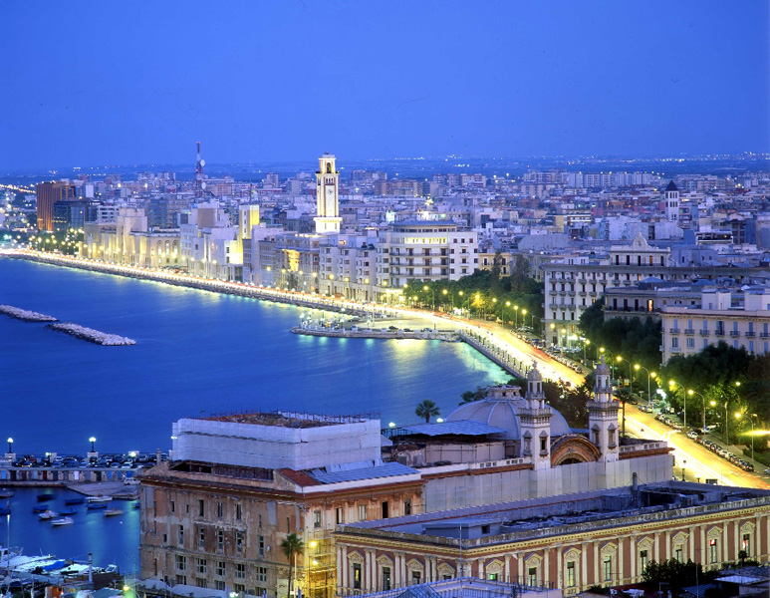
The MA Programme, created by a team of researchers from different backgrounds in the fields of philosophy, politics, economics and law, is targeted at students with a specific interest in combining a preparation in the fundamentals of economics with philosophically informed studies that involve crucial political questions on, for example, globalization, climate change, social solidarity and migration flows. Those who have economics training in their Bachelor degrees will broaden their range of interests and understanding by being exposed to political problems and philosophical methods of analysis and normative reflection.
The MA Programme is a two-year course taught entirely in English that is meant to open up opportunities for work and further research beyond national borders for a generation of students from the Mediterranean area and beyond. The MA offers the opportunity to carry out a part of the studies leading to our PPE master degree in another European university, among which are Witten/Herdecke, Bayreuth, Graz, Bochum, Ulm and others.
The total cost of university tuition is € 2500,00. This amount can be paid in two installments according to the procedure published on the website. https://manageweb.ict.uniba.it/master-universitari/ppe/1
NEW AND IMPORTANT: FROM JUNE 2019 THE LOCAL AUTHORITY (REGIONE PUGLIA–ADISU) WILL LAUNCH A CALL FOR FOREIGN STUDENTS WHO WANT TO STUDY INTERNATIONAL MASTERS IN PUGLIA. THE CALL IS DIRECTED TO DESERVING STUDENTS WITH AN INCOME BELOW € 22,000, AS CERTIFIED BY ISEE.
FINANCIAL AID COVERS ACCOMODATION EXPENSES UP TO € 1900 PER YEAR (UNIVERSITY RESIDENCE COST OF A PLACE IN A DOUBLE ROOM IS € 160 PER MONTH). MEALS ARE FREELY PROVIDED IN UNIVERSITY CAFETERIAS.
UNIVERSITY TUITION IS NOT COVERED.

In order to apply students have to be first enrolled in the master programme. For applications to the PPE please see https://manageweb.ict.uniba.it/master-universitari/ppe/new-2. On this link you can also find info for ‘honour loans’ offered by BancaIntesa. For all info and application please write to ppe.master@uniba.it , Prof. Michele Mangini (PPE coordinator)

