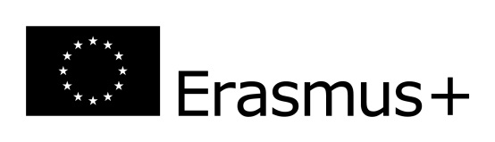
INSTITUTE OF EDUCATION 2016/2017
Courses for ERASMUS student with the groups of Early education and English teaching, Social work
lp | Subject | semester | Hours | ECTS points
 | Supporting the child's development in the early education | winter | 30 | 4
 | Childhood in the contemporary world | winter | 15 | 2
 | Classroom management | winter | 15 | 2
 | Models of early education | summer | 15 | 2
 | Drama and children's play | winter | 20 | 2
 | Techniques of children's art supporting | winter | 20 | 3
 | Techniques of children's music creation | winter | 20 | 3
 | Active learning | winter | 20 | 2
 | Integrated course | Winter/summer | 90/60 | 5/4
 | Creative writing | summer | 60 | 3
 | Methodology of early English education | Winter/summer | 30/30 | 3/3
 | Picture books for children | winter | 10 | 1
 | Early science and experimenting | summer | 30 | 4
 | English for Teachers | Winter/summer | 60/60 | 3/3
 | English Grammar | Winter/summer | 30/30 | 3/3
 | English with elements of phonetics | winter | 30 | 3
 | Small talk | summer | 30 | 4
 | The pedagogy of Maria Montessori at home and early education | winter | 20 | 2
 | Social Policy and European Welfare States-individualy with the teacher | summer | 30 | 3
 | Communication for cooperation and solving conflicts in education) | summer | 25 | 4
 | Polish course | Winter/summer |  | 4/4
ERASMUS EXCHANGE IN 2016-17
Dear future Erasmus students. Please note that full list of courses for both winter and summer semesters of 2016/17 academic year will be available on September. Some lectures will be activated after the elections made ​​by the students and the list of items presented in September.
The coordinator of pedagogy:
Magdalena Sawicz wnsms@ug.edu.pl, Room A415 Tuesday, Thursday 8:00-15:00 and arranged meetings

